**Using appsettings.json in Windows Forms**

1. Tools → NuGet Package Manager → Manage NuGet Packages for Solution

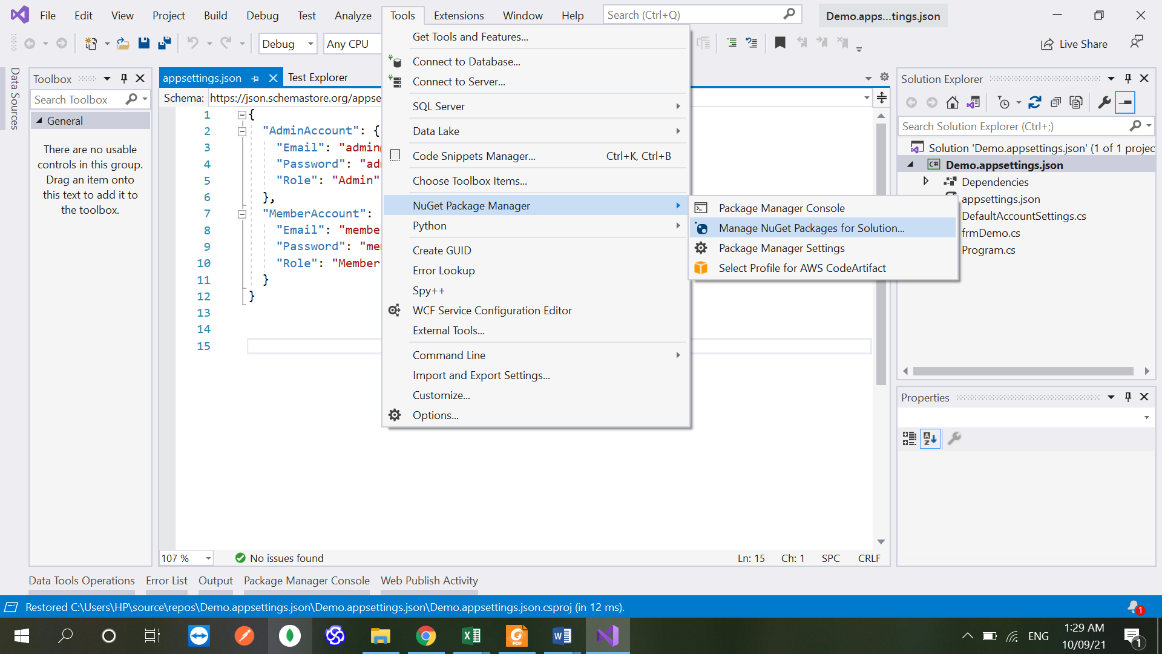

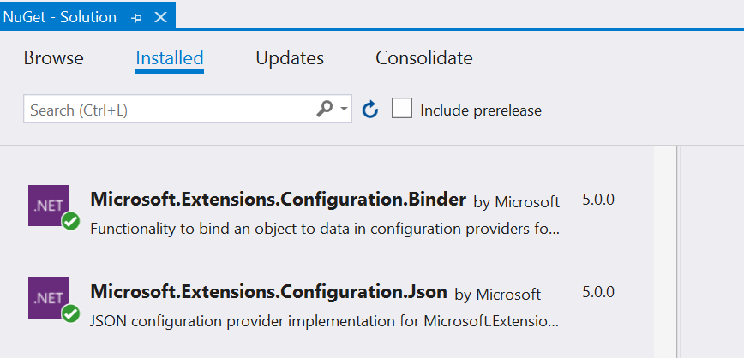

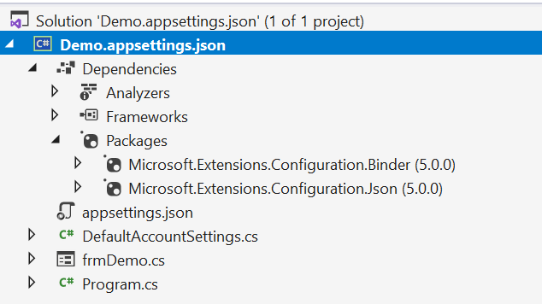

1. Add appsettings.json to root folder of project

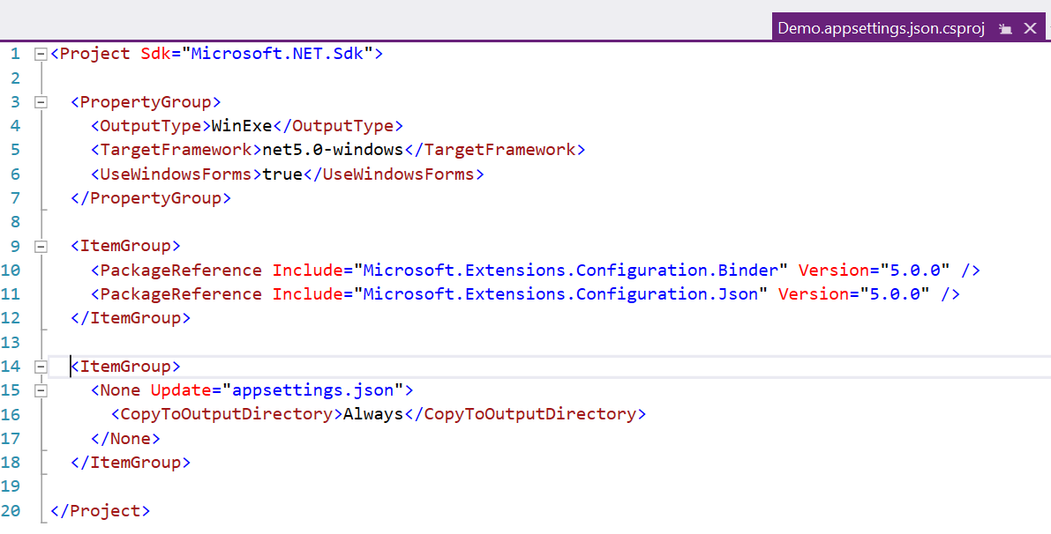

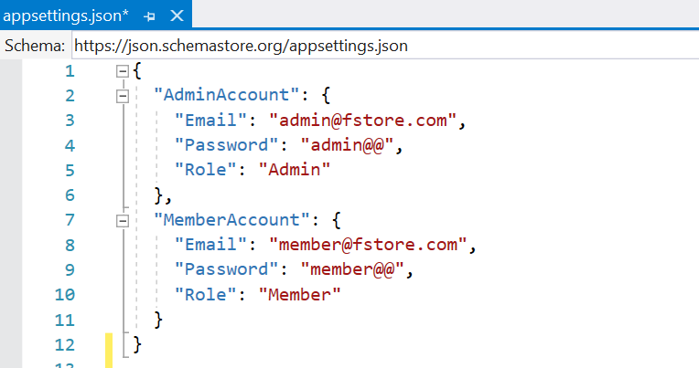

1. Change in Program.cs

using Microsoft.Extensions.Configuration;

using System;

using System.Windows.Forms;

namespace Demo.appsettings.json

{

static class Program

{

public static IConfiguration Configuration;

/// <summary>

/// The main entry point for the application.

/// </summary>

[STAThread]

static void Main()

{

var builder = new ConfigurationBuilder().AddJsonFile("appsettings.json", optional: true, reloadOnChange: true);

Configuration = builder.Build();

Application.SetHighDpiMode(HighDpiMode.SystemAware);

Application.EnableVisualStyles();

Application.SetCompatibleTextRenderingDefault(false);

Application.Run(new frmDemo());

}

}

}

1. Create class for setting information

public class DefaultAccountSettings

{

public string Email { get; set; }

public string Password { get; set; }

public string Role { get; set; }

}

1. Read sections in appsettings.json file

using Microsoft.Extensions.Configuration;

…

var adminDefaultSettings = Program.Configuration.GetSection("AdminAccount").Get<**DefaultAccountSettings**>();

string email = adminDefaultSettings.Email;

string password = adminDefaultSettings.Password;

string role = adminDefaultSettings.Role;